**Project Title:**

**TripAdvisor E-Management**

College Name: **MAILAM ENGINEERING COLLEGE**

Code: **4216**

**Department of Computer Science Engineering**

**Team Leader:**

Name: ABIRAMAN M Reg No: 421622104001

**Team Members:**

|  |  |
| --- | --- |
| Name: ARJUN M | Reg No: 421622104012 |
| Name: BALAVENTHAN I | Reg No: 421622104018 |
| Name: HARIHARAN S | Reg No: 421622104043 |

**TripAdvisor E-Management**

**Hardware Required:**

* System with advance configuration

**Software Required:**

* Salesforce Platform

**System Required:**

* Good Configuration
* The TripAdvisor E-Management app with the salesforce works with your all-in-one travel companion, empowering you to plan, book, and make the most of the trips. Discover millions of reviews and insights shared by fellow travelers, helping you make informed decisions for every aspect of your journey. Whether you're seeking the perfect hotel, top-rated restaurants, must-visit attractions, or the best travel deals, TripAdvisor has you covered.
* **Acceptance Criteria & Solution**
* As the Salesforce User we have to manage the data for the Hotels, Flights, and Food Options for this we have to create some automation for simplification.
* To ensure that when a new Food Option is added or updated, the corresponding Hotel's information is
* updated accordingly. For example, you might want to maintain a total count of food options for each hotel.

Also there is automation for the customer benefits if the there buying amount is with respect to some amount then they will get some discounts on their bill

* For the flights there schedule process being involved where the customer who has booked the flight will get the reminder mail alert for knowing proper timing of the flight before 24 hrs it's important to manage the in a good way.
* The system should provide confirmation or notification to the user upon successful sending of the email.
* Solution:  For the Above requirements of TripAdvisor we have created the solutions by creating the custom objects and Fields the Custom Objects that are created are  Hotels, Food Options, Customer & Flights. For the Automation we have used here a flow and triggers and for scheduling the email alerts we

have created the Apex Schedulable class so email alerts will be created.

* **Create Object**
* Hotel Object is created to ensure that when a new Food Option is added or updated with the necessary information
* Enter label : Hotel

* Plural Name : Hotels
* Data Type : (text)
* Field Name : Hotel Name
* Click Allow Reports
* Allow Search ? Save
* With Above References Create following Object
* Food Option ? Data Type ? Auto Number ? Format?  FO - {0000}
* Flight ? Data Type ? Auto Number ? Format?  FL- {0000}
* Customer ?Text ? Field Name ? Customer Name

**Create Fields for Hotel Object**

|  |  |  |
| --- | --- | --- |
| * Sr. No. | * Field Name | * Data Type |
| * 1 | * TotalFoodOptions | * Number |
| * 2 | * Date | * Date |

### Create Fields For Food Option

|  |  |  |
| --- | --- | --- |
| **Sr. No.** | **Field Name** | **Data Type** |
| 1 | Name | Text |
| 2 | Hotel | Hotel(Lookup) |
| 3 | Food Amount | Currency |

### Create Fields in the Flight Object

|  |  |  |
| --- | --- | --- |
| **Sr. No.** | **Field Name** | **Data Type** |
| 1 | Name | Date/Time |
| 2 | DepartureDateTime | Hotel(Lookup) |

### Create Fields in the Customer Object

|  |  |  |
| --- | --- | --- |
| **Sr. No.** | **Field Name** | **Data Type** |
| 1 | Customer Name | Name |
| 2 | Discount Amount | Formula (Currency) |
| 3 | Discount Percent | Percentage |

### Create Flow

Create the Flow for the discount for customer when the Amount is greater than 3000  somesome Amount of Discounts will be there if the Amount is between 1500 to 3000 so Some Amount of Discount will be there for them

### Flow Procedure

**Create 3 variable :**

Variable >Api name >foId> text > Available for Input

Variable >Api name >csId> text > Available for Input

Variable >Api name > discount > Number

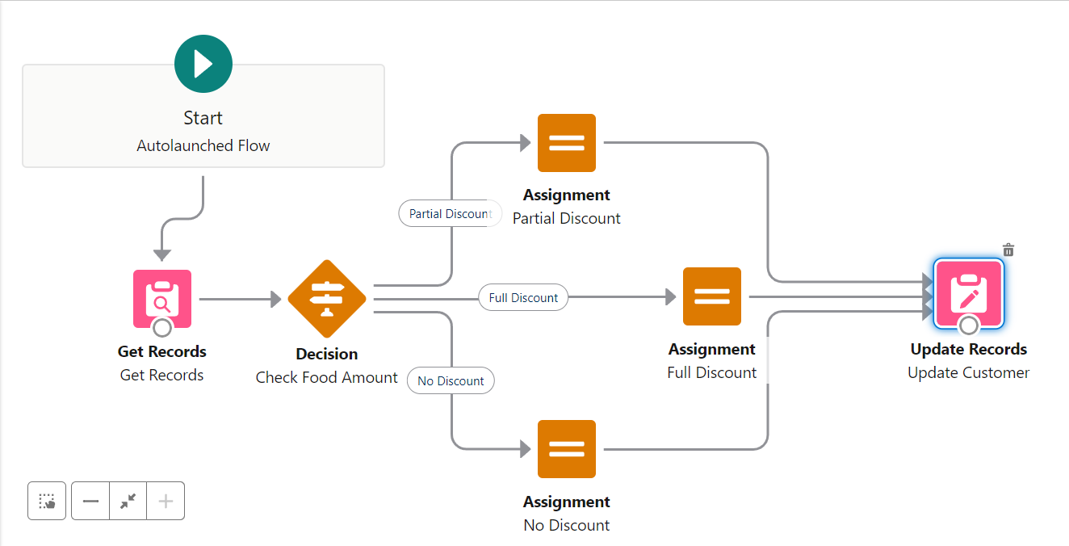

**Flow Steps :**Get Records

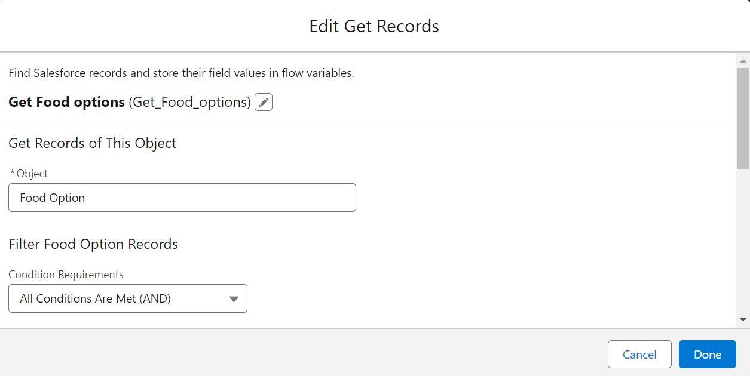

2. Decision Element: Create 2 Outcomes

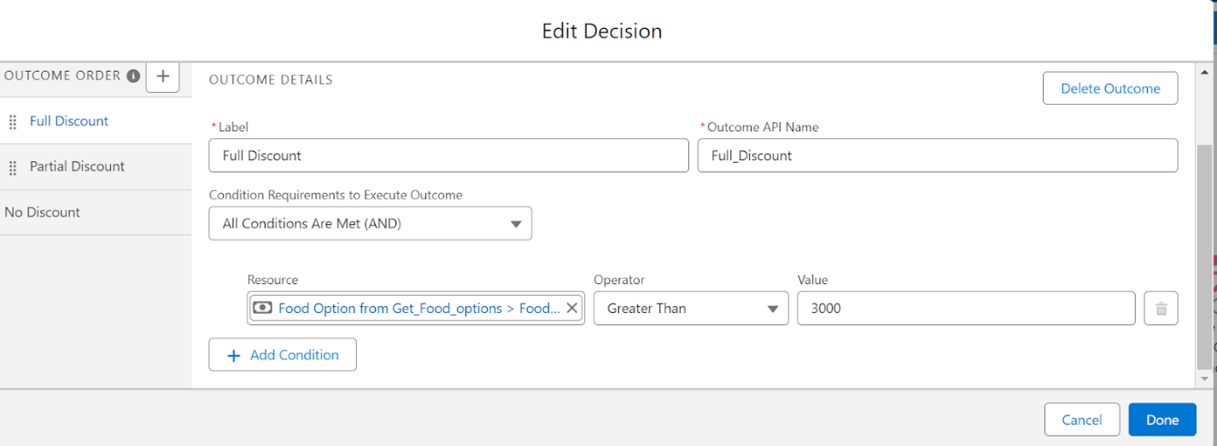

Take the 3 Assignments > Full Discount, Partial Discount & No Discount

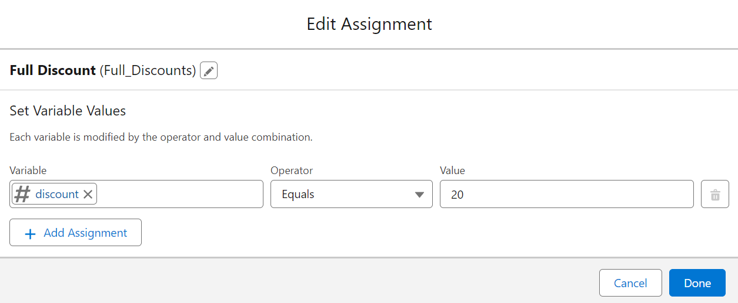

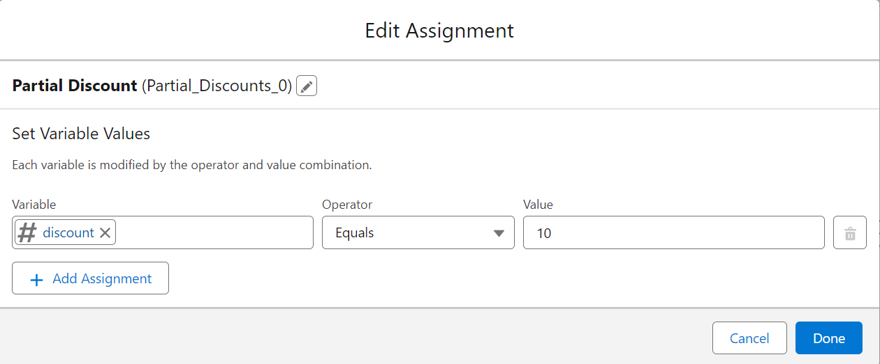Edit Assignment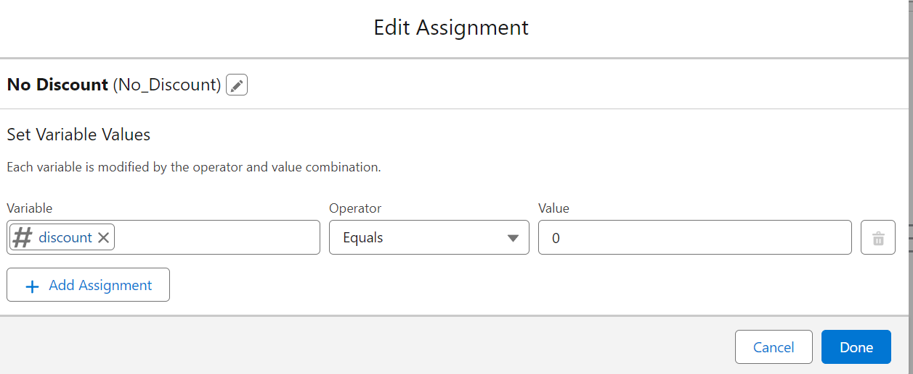

**Update Record Element**

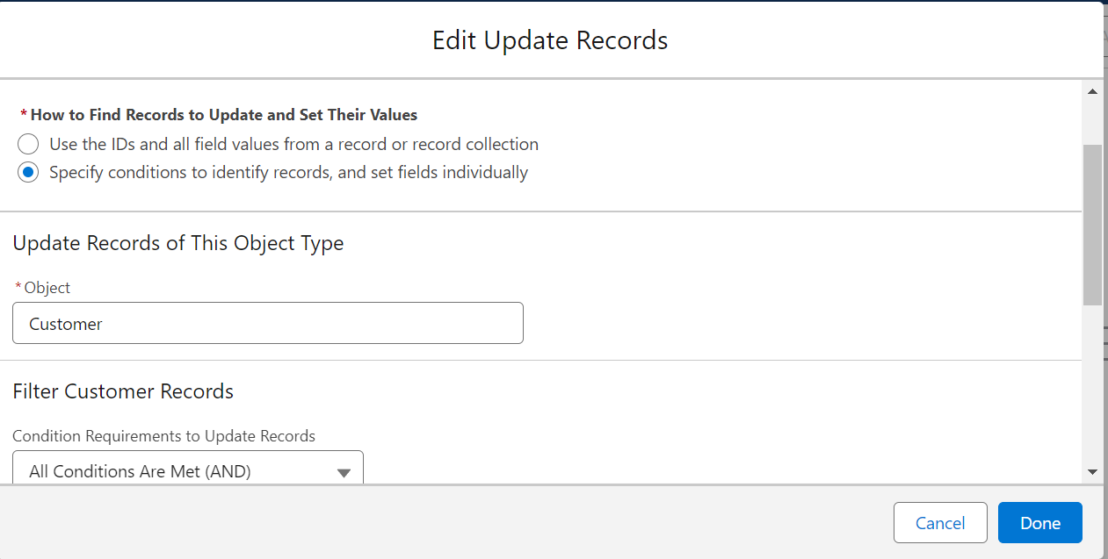

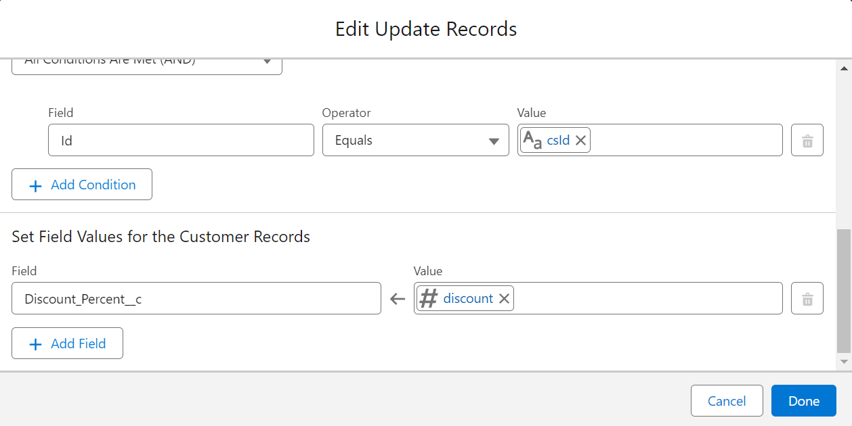

### Apex Triggers

Scenario: In the Hotel you have to ensure that when a new Food Option is added or updated, the corresponding Hotel's information is updated accordingly. For example,

you might want to maintain a total count of food options for each hotel. To manage the things properly with perspective to the Hotel things should be clearly manageable for making the food options available with respect to hotels

### Apex trigger With Handler

Apex Trigger With Handler

public class FoodOptionTriggerHandler {

    // Method to update hotel information based on food options

    public static void updateHotelInformation(List<Food_Option__c>newFoodOptions, List<Food_Option__c>oldFoodOptions, TriggerOperation operation) {

        Set<Id>hotelIdsToUpdate = new Set<Id>();

        // Collect unique Hotel Ids affected by food options changes

        for (Food_Option__cfoodOption :newFoodOptions) {

            hotelIdsToUpdate.add(foodOption.Hotel__c);

        }

        // Update hotel information based on food options

        List<Hotel__c>hotelsToUpdate = [SELECT Id, Name, TotalFoodOptions__c FROM Hotel__c WHERE Id IN :hotelIdsToUpdate];

        for (Hotel__chotel :hotelsToUpdate) {

            // Recalculate total food options count

            Integer totalFoodOptions = [SELECT COUNT() FROM Food_Option__c WHERE Hotel__c = :hotel.Id];

            hotel.TotalFoodOptions__c = totalFoodOptions;

        }

        // Update hotels with new total food options count

        update hotelsToUpdate;

    }

}

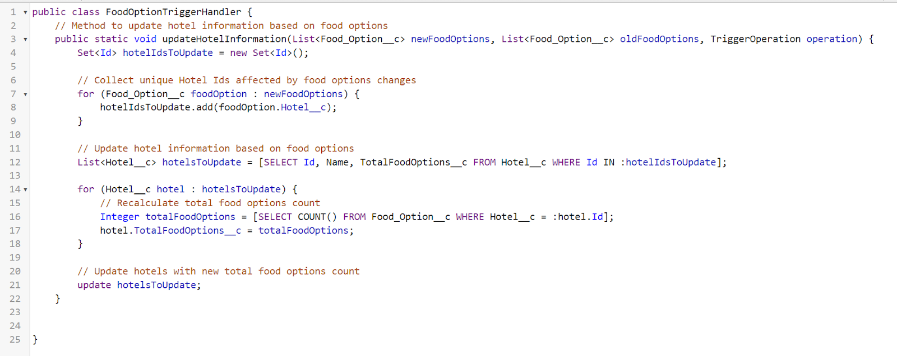

Trigger

trigger FoodOptionTrigger on Food_Option__c (after insert, after update, after delete) {

    If(trigger.isInsert&&trigger.isAfter){

     FoodOptionTriggerHandler.updateHotelInformation(trigger.new);

    }

}

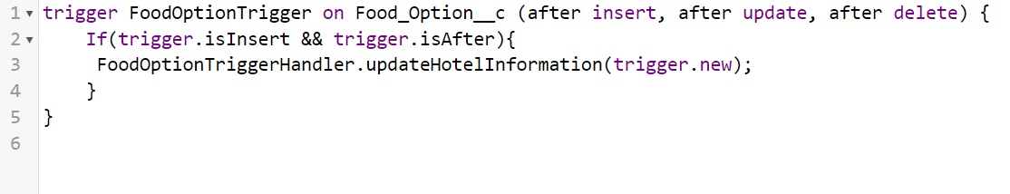

* **Apex Schedule**
* Create the Reminder mail for the customer who has booked the flight according to that booking set the Apex schedule so mail will be sent prior to 24hrs.

* Note: Please create the required field for Scheduled Apex Code

**Apex Schedule Class Solution**

* public class FlightReminderScheduledJob implements Schedulable {
* public void execute(SchedulableContextsc) {
* sendFlightReminders();
* }

* private void sendFlightReminders() {
* // Query for flights departing within the next 24 hours
* List<Flight__c>upcomingFlights = [SELECT Id, Name, DepartureDateTime__c FROM Flight__c
* WHERE DepartureDateTime__c >= :DateTime.now()

* AND DepartureDateTime__c <= :DateTime.now().addDays(1)];
* for (Flight__cflight :upcomingFlights) {
* // Customize the logic to send reminder emails
* // For this example, we'll print a log message; replace this with your email sending logic.
* System.debug('Sending reminder email for Flight ' + flight.Name + ' to ' + flight.ContactEmail__c);
* // Example: Send email using Messaging.SingleEmailMessage
* Messaging.SingleEmailMessage email = new Messaging.SingleEmailMessage();
* email.setToAddresses(new List<String>{ flight.ContactEmail__c });
* email.setSubject('Flight Reminder: ' + flight.Name);
* email.setPlainTextBody('This is a reminder for your upcoming flight ' + flight.Name +
* ' departing on ' + flight.DepartureDateTime__c);
* Messaging.sendEmail(new List<Messaging.SingleEmailMessage>{ email });
* }
* }
* }
* 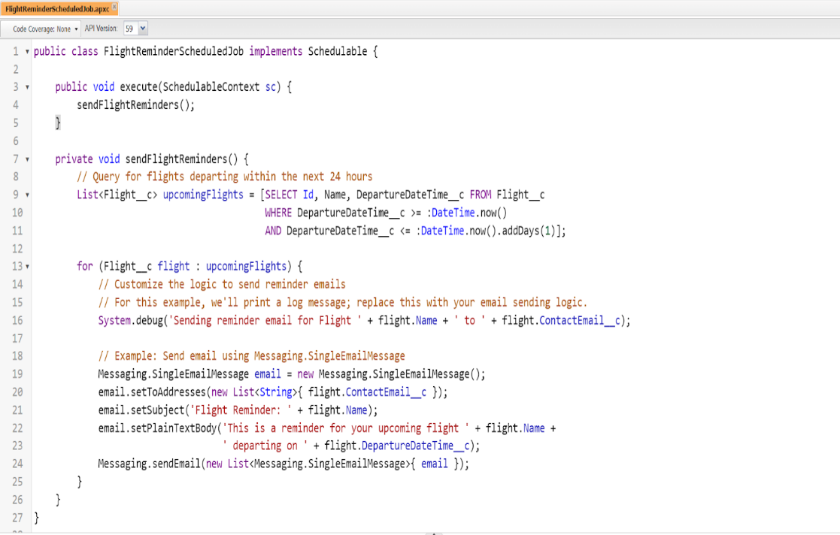
* The FlightReminderScheduledJob class implements the Schedulable interface, and the execute method is where you put the logic to send reminder emails.
* The sendFlightReminders method queries for flights departing within the next 24 hours. You can customize the query based on your specific requirements.

* Create the Apex code in an anonymous Window to execute the Apex Code
* // Schedule the job to run every day at a specific time (e.g., 6 AM)
* String cronExp = '0 0 6 * * ?';
* System.schedule('FlightReminderJob', cronExp, new FlightReminderScheduledJob());
* 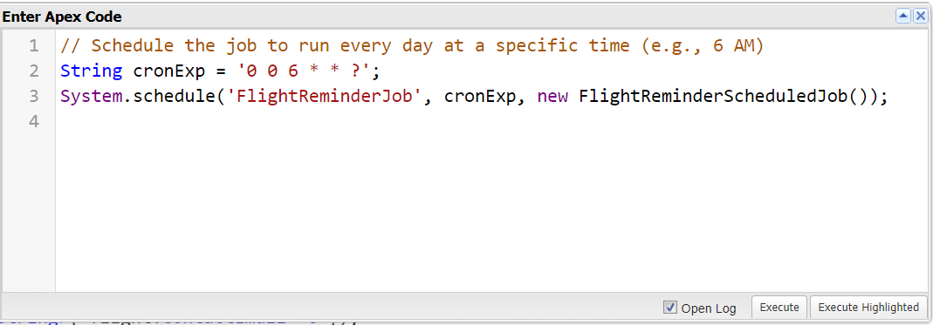
* Conclusion: We have Created this Customization  process for the proper flow of the

business if TripAdvisor where they can easily access the Hotel requirement then food options and also the ease for the customers with the preferable discount with there Amount limits this process helps to save time from multiple manual processes.